s

TDENGINE CUSTOM DATA REFERENCE
User Manual

Table of Contents
Introduction 2
Installation & Configuration 3
1. Register the DLL files with TDengine PI Custom Data Reference Installer 3
2. Setting up the AF Configuration Database 5
Setting up the ConfigString 9
PI Point Mode 10
AF Element Mode 11
Table Mode 12
Creating tables on TDengine 13
Methods Overloaded 14
Snapshot 14
RecordedValue 14
RecordedValues 14
RecordedValuesAtTime 14
RecordedValuesByCount 14
InterpolatedValue and InterpolatedValues 14
PlotValues 14
Summary 14
Summaries 14
UpdateValue 14
Troubleshooting 15
TDengine Support 17

Introduction

The TDengine Data Reference (TDengine DR) is a custom AF Data Reference that allows PI AF to communicate with TDengine.
An AF Attribute properly configured with the TDengine DR behaves like an AF Attribute configured with the PI Point Data Reference (PI Point DR). While the PI Point DR connects to the PI Data Archive, the TDengine DR connects to TDengine Cloud or a local TDengine cluster.
The following features are available on the TDengine DR:
- Retrieve snapshot data
- Retrieve recorded values
- Retrieve interpolated values
- Retrieve summary values
- Write values to TDengine
As a result, you can use the TDengine DR for:
- View trends in PI Vision
- View snapshot values in PI Vision
- Calculate the maximum and average values for a given interval
- Store PI Analysis output values
Note that the TDengine DR does NOT copy your data from TDengine to the PI Data Archive. It reads values from TDengine through HTTP requests and displays the results to the user.
TDengine DR extends the features of your PI System with a powerful hybrid solution with TDengine, a modern time series database.

Installation & Configuration

There is no setup kit for installing the TDengine DR since it is only necessary to register the DLL as an AF plugin.
An overview of the registration process is listed below:
- Register the DLL files with TDengine PI Custom Data Reference Installer
- Setup the AF Configuration Database with PI TDengine Connection Manager

Register the DLL files with TDengine PI Custom Data Reference Installer
Open the setup kit TDEngineDR.Setup.exe and connect to the AF Server that you want to install the plugin as shown on Figure 1.
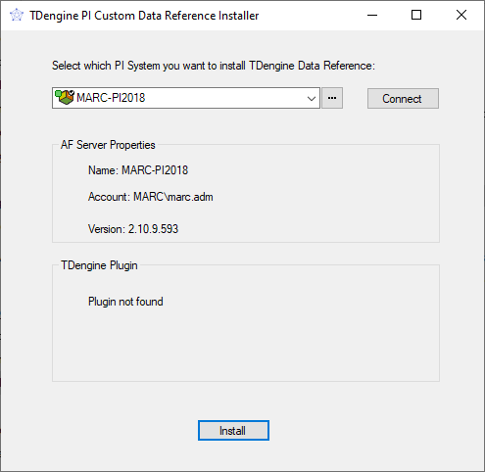
Figure 1 – TDengine PI Custom Data Reference Installer

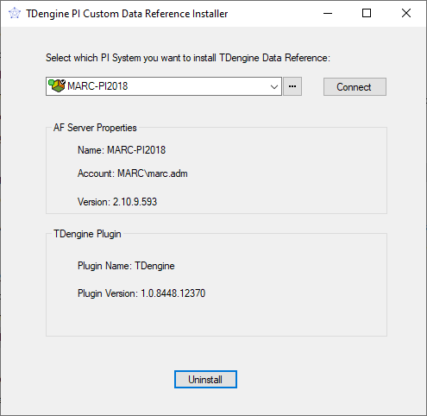
Figure 2 – TDengine PI Custom Data Reference Installer showing the plugin was registered successfully.

Click on the “Install” button to register the TDengineDR.dll plugin in the connected AF Server. In case of success, you will see information about the plugin in the setup application.

Open PI System Explorer and go to the Plugin tab of the PI AF Server Properties as shown on Figure 3. Note: if you had the PI System Explorer opened while installing the plugin, then you will need to close it and re-open it for the TDengine plug-in to show up in the Plug-Ins list.
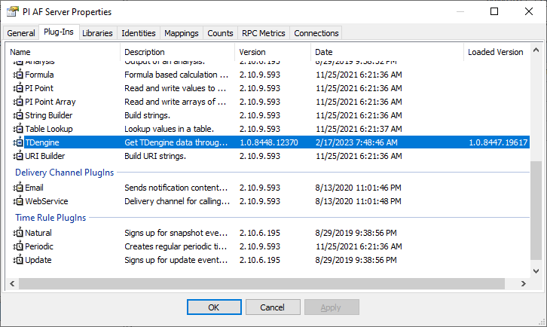
Figure 3 – AF Plugins registered.

Make sure that the TDengine plugin appears on the list.

Setting up the AF Configuration Database
The TDengine DR reads data from the AF Configuration database in order to connect to the TDengine servers.
Before adding a new TDengine server in AF, please go to cloud.tdengine.com, login into your account (or create one first) and then on the left menu, go to “Instances”.

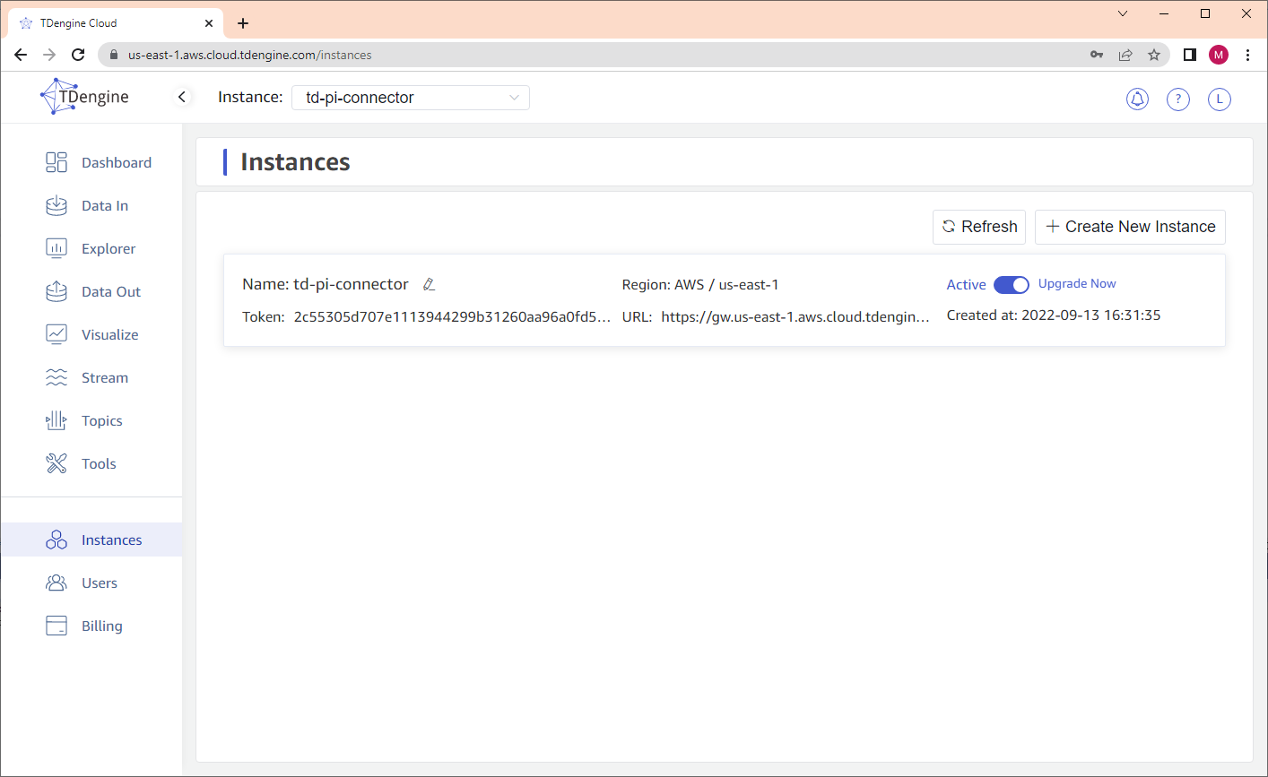
Figure 4 – TDengine Cloud Instances

Open PI TDengine Connection Manager and connect to the same AF Server that the plugin was installed as shown on Figure 5.
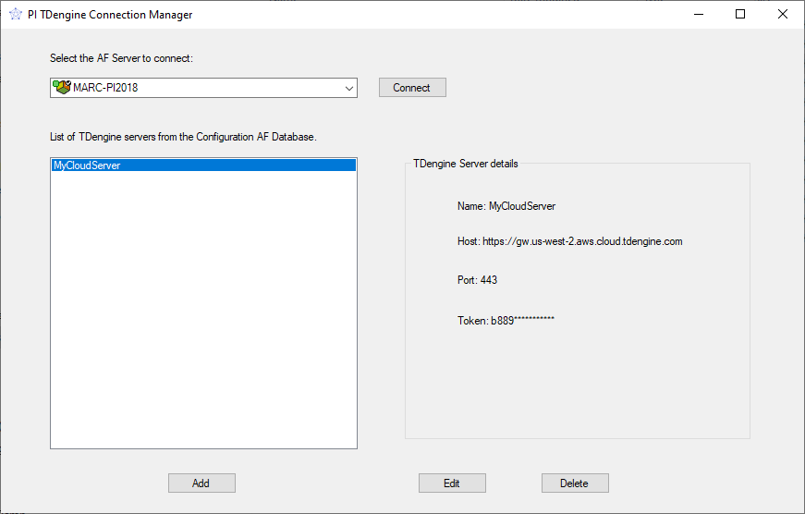

Figure 5 – PI TDengine Connection Manager

Click on the “Add” button to add a new TDengine Server to the list as shown on Figure 6.

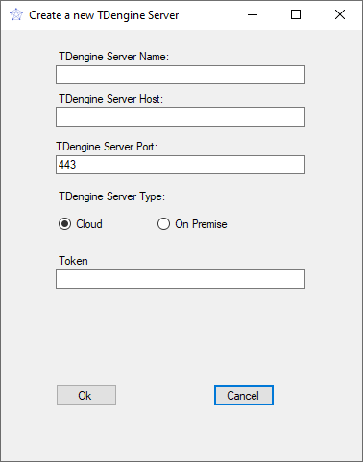
Figure 6 – Adding a new TDengine Server.

After clicking in “Ok” the application will try to connect to the TDengine Server. If the connection is successful, the server will be added to the list successfully.
If you open PI System Explorer and open the configuration AF database, you should see the server Element created under TDengine\Servers (Figure 7). The token and password are encrypted to increase the security.

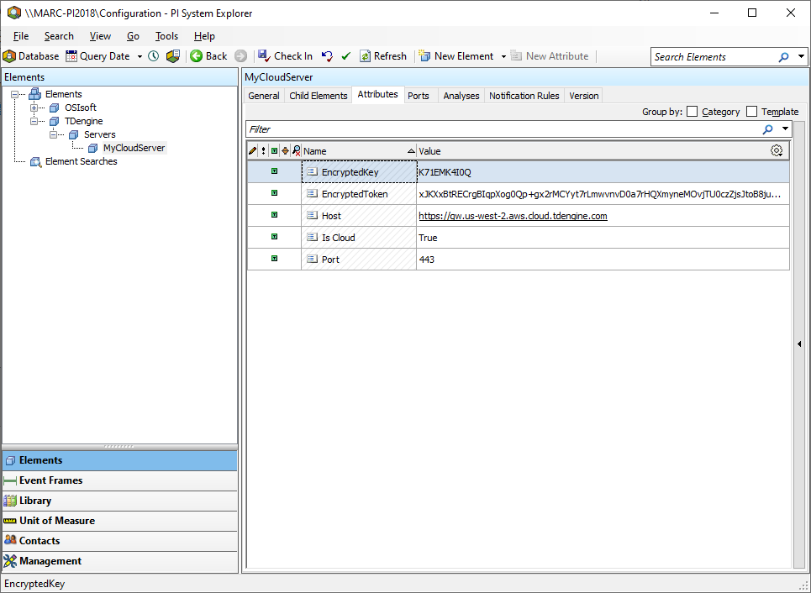
Figure 7 – TDengine Cloud AF Element

Note that the TDengine DR requires TDengine server version 3.0.1.5 or later.

Setting up the ConfigString
After setting up the Configuration database, create an AF attribute and select “TDengine” as the Data Reference (Figure 8).

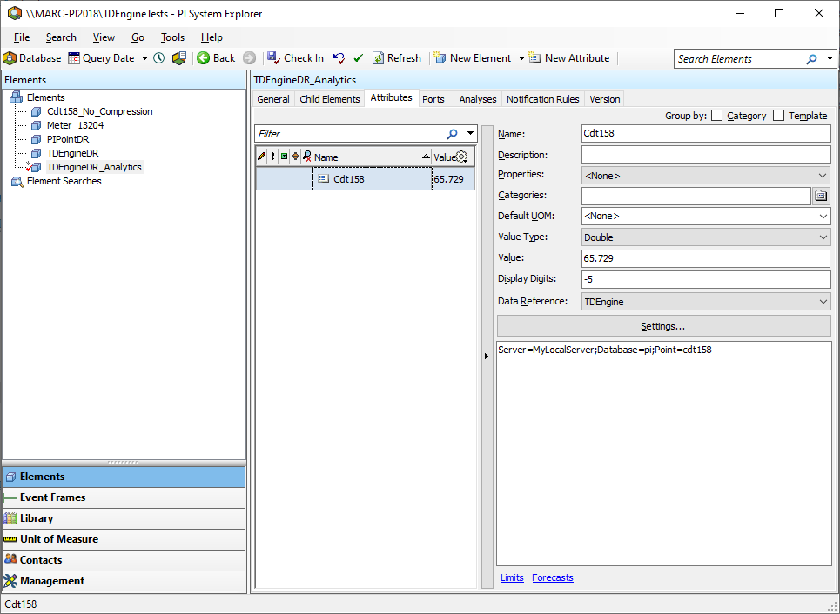
Figure 8 – Configuring the TDengine DR
Click on “Settings…”. The ConfigString editor opens allowing the user to select a TDengine Server configured on the AF Configuration database.
The TDengine DR works with three modes: PI Point, AF Element and Table.

PI Point Mode
When using the PI Point mode, the “Database” and “Point” text boxes should be filled as shown on Figure 9. The TDengine DR retrieves values from the columns from the table whose name is the point name.
Let’s suppose the Point name is “cdt158”. The TDengine table cdt158 created for this mode has the following columns:
- ts (DATETIME),
- val(ANY)
- quality(INT)
The type of the val column should be compatible with the AF Attribute Value Type. Nevertheless, if the table in TDengine is created through the TDengine DR or through the TD PI Connector, the correct column type would be created automatically.
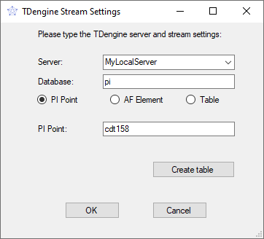
Figure 9 – TDengine DR for PI Point mode

AF Element Mode
When using the AF Element mode, the “Database”, “Element” and “Attribute” text boxes should be filled as shown on Figure 10. The TDengine DR retrieves values from the columns from the table whose name is the element name.
Let’s suppose the Element name is “Chicago” and the “Attribute” is “Pressure”. The TDengine table created for this mode has the following columns:
- ts (DATETIME),
- pressure_val(ANY)
- pressure_status(INT)
The type of the pressure_val column should be compatible with its AF Attribute Value Type. This type of table should be created automatically TD PI Connector as the TDengine DR cannot create tables of this type.

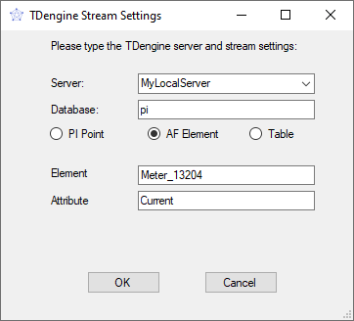
Figure 10 – TDengineDR for AF Element mode

Table Mode
When using the Table mode, the “Database” , “Table” and “Column” text boxes should be filled as shown on Figure 11. The TDengine DR retrieves values from the columns from the table whose name is the table name.
Let’s suppose the Table name is “meter” and the “Column” is “current”. The TDengine table created for this mode has the following columns:
- ts (DATETIME),
- current(ANY)

The type of the current column should be compatible with its AF Attribute Value Type.
This mode is used to facilitate reading any tables and columns from TDengine. Note that PI Point and AF Element modes read 3 columns per PI Point or AF Attribute: timestamp, value and quality. This mode only reads 2 columns: timestamp and value. The quality column is not used in this mode.

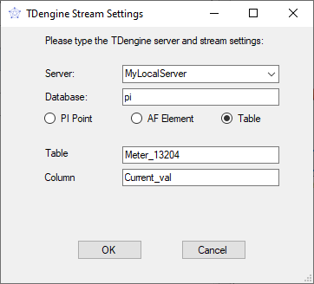
Figure 11– TDengine DR for Table mode

Creating tables on TDengine
If you are using PI Point mode, the TDengine DR can create tables on TDengine automatically with the correct type. This can be done by clicking on the “Create table” button shown on Figure 6. A new window will be opened as shown on Figure 12:
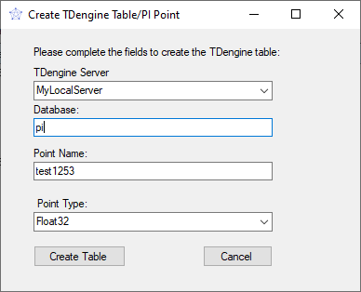
Figure 12 – Creating tables with TDengine DR
After selecting those fields and clicking on the “Create table” button again, the TDengine DR creates a TDengine table called cdt158a with the following columns:
- ts – TIMESTAMP
- val – NCHAR/INT/FLOAT/DOUBLE/TIMESTAMP according to the selected point type
- status - INT
Table 1 shows how the TDengine DR chooses the TDengine column type of the val column according to the selected point type.
Point Type | TDengine Column Type
Digital | NCHAR
Int16 | INT
Int32 | INT
Int64 | INT
Float16 | FLOAT
Float32 | DOUBLE
Float64 | DOUBLE
String | NCHAR
Timestamp | TIMESTAMP
Table 1 – Mapping between the selected Point Type and the TDengine Column Type

Methods Overloaded
Instructions to create a PI Point table on TDengine

Snapshot
Select * from cdt158 ORDER BY ts DESC limit 1;

RecordedValue
Select * from cdt158 WHERE ts = ‘2021-11-26 11:52:23’

RecordedValues
Select * from cdt158 WHERE ts >= ‘2021-11-25 11:52:23’AND ts <= ‘2021-11-26 11:52:23’

RecordedValuesAtTime
Select * from cdt158 WHERE ts = ‘2021-11-25 11:52:23’ OR ts = ‘2021-11-26 11:52:23’

RecordedValuesByCount
Select * from cdt158 WHERE ts >= ‘2021-11-26 11:52:23’ LIMIT 5;

InterpolatedValue and InterpolatedValues
Select interp(val) from cdt158 RANGE(‘2021-11-25 11:52:23’, ‘2021-11-26 11:52:23’) EVERY(1d) FILL(LINEAR)

PlotValues
This method calculates the interval timespan based on the number of intervals and then it calculates the interpolated values.

Summary
Select AVG(val), COUNT(val), MAX(val) ), MIN(val), SUM(val), STDDEV(val) from cdt158 WHERE ts >= ‘2021-11-25 11:52:23’AND ts <= ‘2021-11-26 11:52:23’

Summaries
Select _WSTART, AVG(val), COUNT(val), MAX(val) ), MIN(val), SUM(val), STDDEV(val) from cdt158 WHERE ts >= ‘2021-11-25 11:52:23’AND ts <= ‘2021-11-26 11:52:23’

UpdateValue
Insert into Cdt158 VALUES (‘2021-11-26 11:52:23’, 23, 0), if data is in good quality state
OR
Insert into Cdt158 VALUES (‘2021-11-26 11:52:23’, NULL, 253) if data is in bad quality state

Troubleshooting
A great tool to troubleshoot issues with the TDengine DR is Fiddler.
The Fiddler tool helps debug web applications by capturing network traffic between the Internet and test computers. The tool enables you to inspect incoming and outgoing data to monitor and modify requests and responses before the application receives.
Figure 13 shows that the TDengineDR made an HTTP request against TDengine with the following SQL query:
select ts, val, quality from cdt158 ORDER BY ts DESC limit 1;

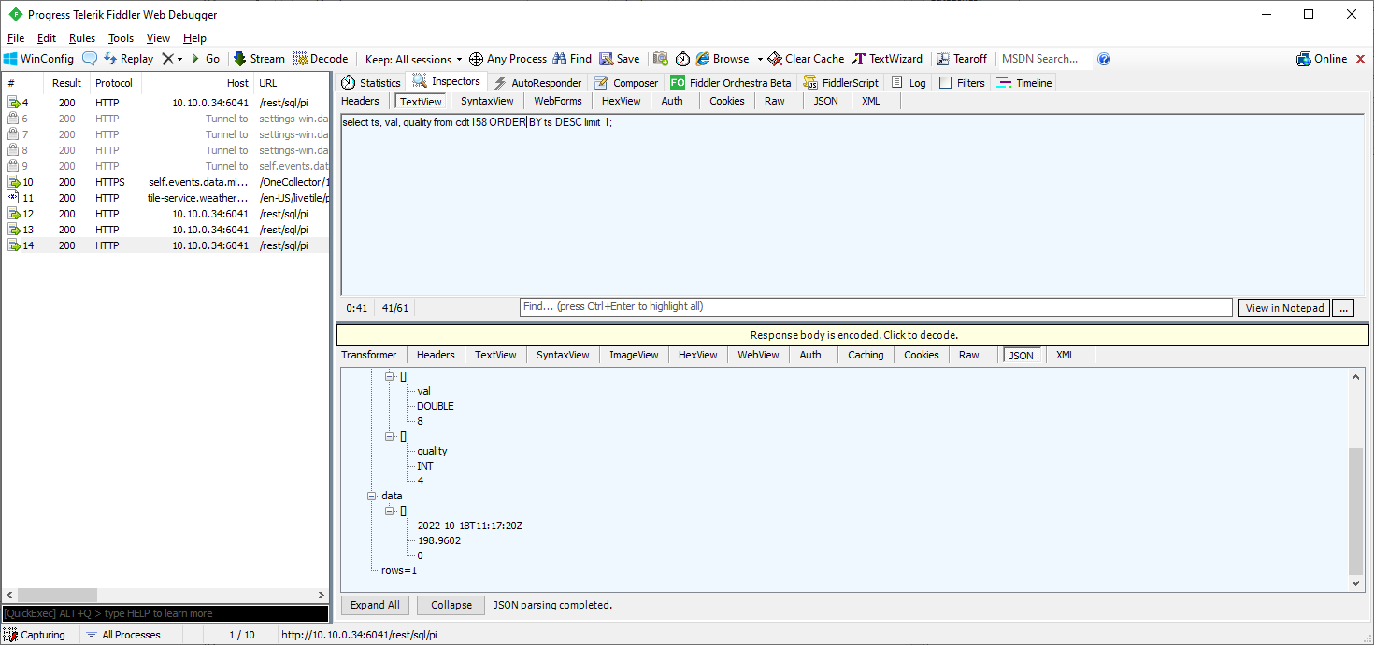
Figure 13 – Fiddler showing HTTP requests made by the TDengine DR against TDengine

The HTTP response contains the value 198.9602 which is what PI System Explorer is showing on Figure 14.
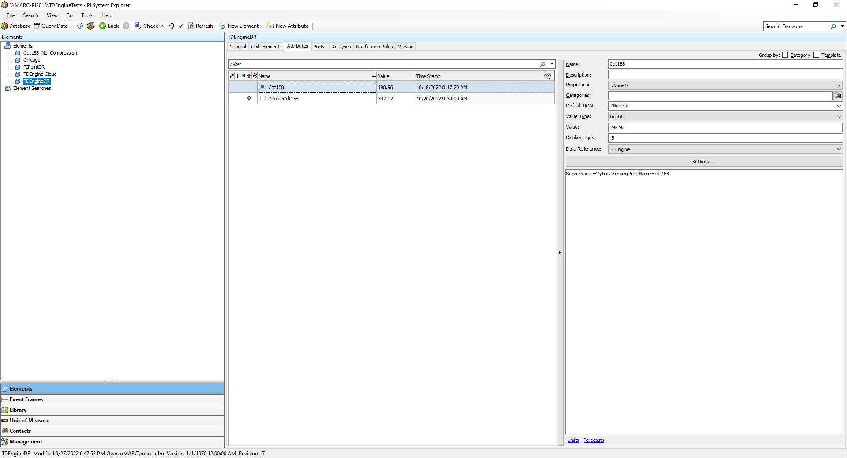
Figure 14 – PI System Explorer showing snapshot data of the CDT158 Attribute using the TDengine DR.

If there is a problem with the DR, it is likely that it would be a consequence of an error in the HTTP request. Note that a 200 HTTP Status Code does not mean that the operation was successful. The HTTP body message needs to be analyzed to confirm.

TDengine Support

If you are an Enterprise Edition customer or interested in enterprise services, contact business@tdengine.com to speak with an account representative.
For more information about TDengine, you can follow us on social media and join our Discord server.

